

**WEB 2 FINAL PROJECT**

**Pharmacy Company**

**Rami Yahya 202110882**

**Hamza Alaedi 202010504**

**Mohammad Smadi 202010498**

**SUPERVISED BY: DR. ABDO AL-KHOURY**

**2023-2024 2ND SEMESTER**

**Users and Passwords**

**HR manager: rami rami1234**

**HR employee: ali ali1234**

**Warehouse Manager: hamza hamza1234**

**Warehouse Employee : mhd mhd1234**

**Marketing Manager : mohamad mohamad1234**

**Marketing Employee : osama osama1234**

**Delivery Employee : baraa baraa**

**Customer : khalid khalid**

Software’s that we used to finish this project:

* Microsoft SQL Server "SSMS"(create a database named “pharmacy” then import the sql file).
* IDE visual studio 2022

Some essential libraries :

* using System.Configuration;
* using System.Data.SqlClient;
* Using System.data

PROJECT MAIN PAGES:

**Login :**

**the Login page is unified for all users of the system, Login.aspx. The user enters his username and password and what type of user he is then if the information are valid he will be transferred to his home page.**

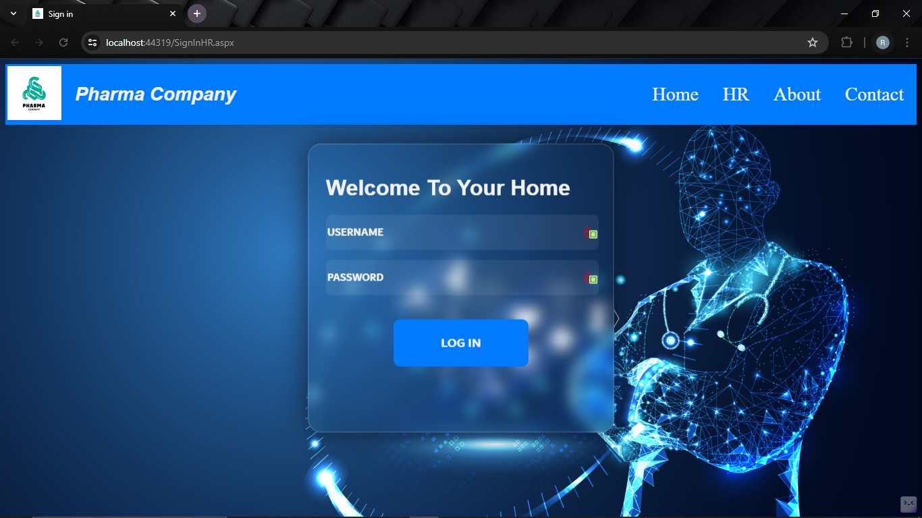

**Home:**

**The person must be an employee or manager to be able to enter the administration of each block according to his job and according to which block you want to enter there He can enter as the HR, Warehouses, Marketing & Customers as manager or employee. He can add, update and delete managers. He can log out of his account as well.**



**HR :**

**This block is the basic structure of the project, which contains all the elements and related parts of the rest of the blocks where there is the HR employee and the HR manager.**

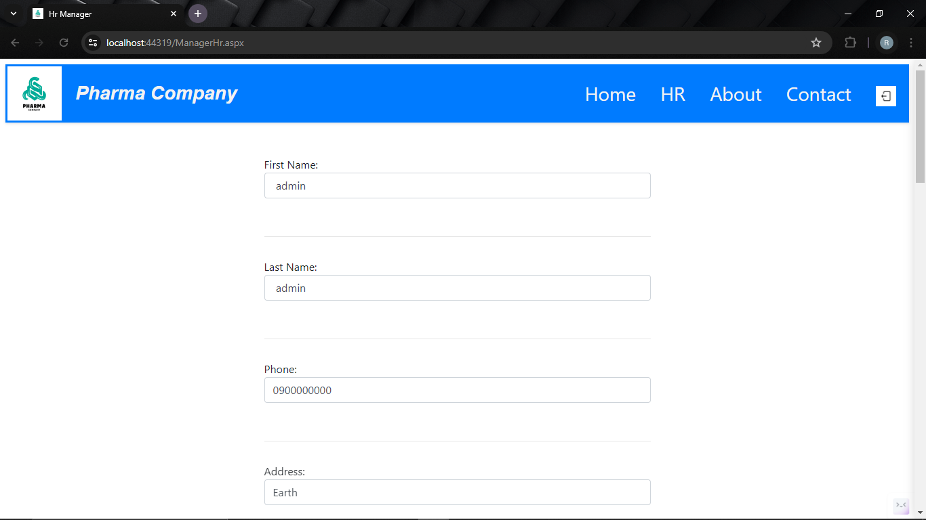

**The HR employee can Insert and Update Products on Database and show operations in grid view. employee_HR.aspx**

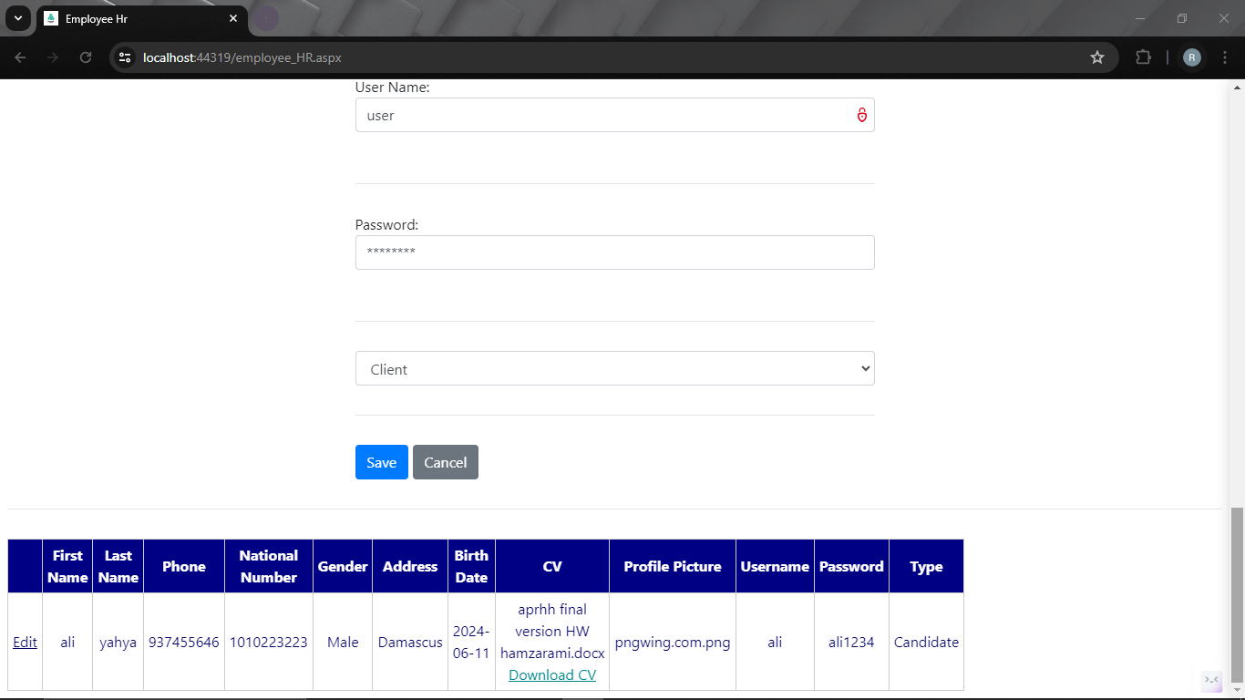

**The HR employee can Insert and Update Products on Database and show operations in grid view. employeeindex.aspx**

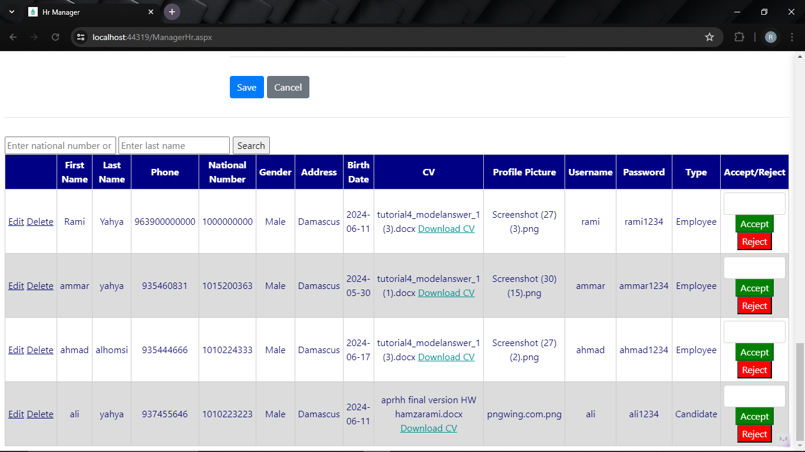

**The HR Manager can Insert Update and Delete and Evaluate Products on Database and show operations in grid view . ManagerHR.aspx**

**Warehouse :**

This block's primary function is to provide the database with products and showrooms management to display customers products.

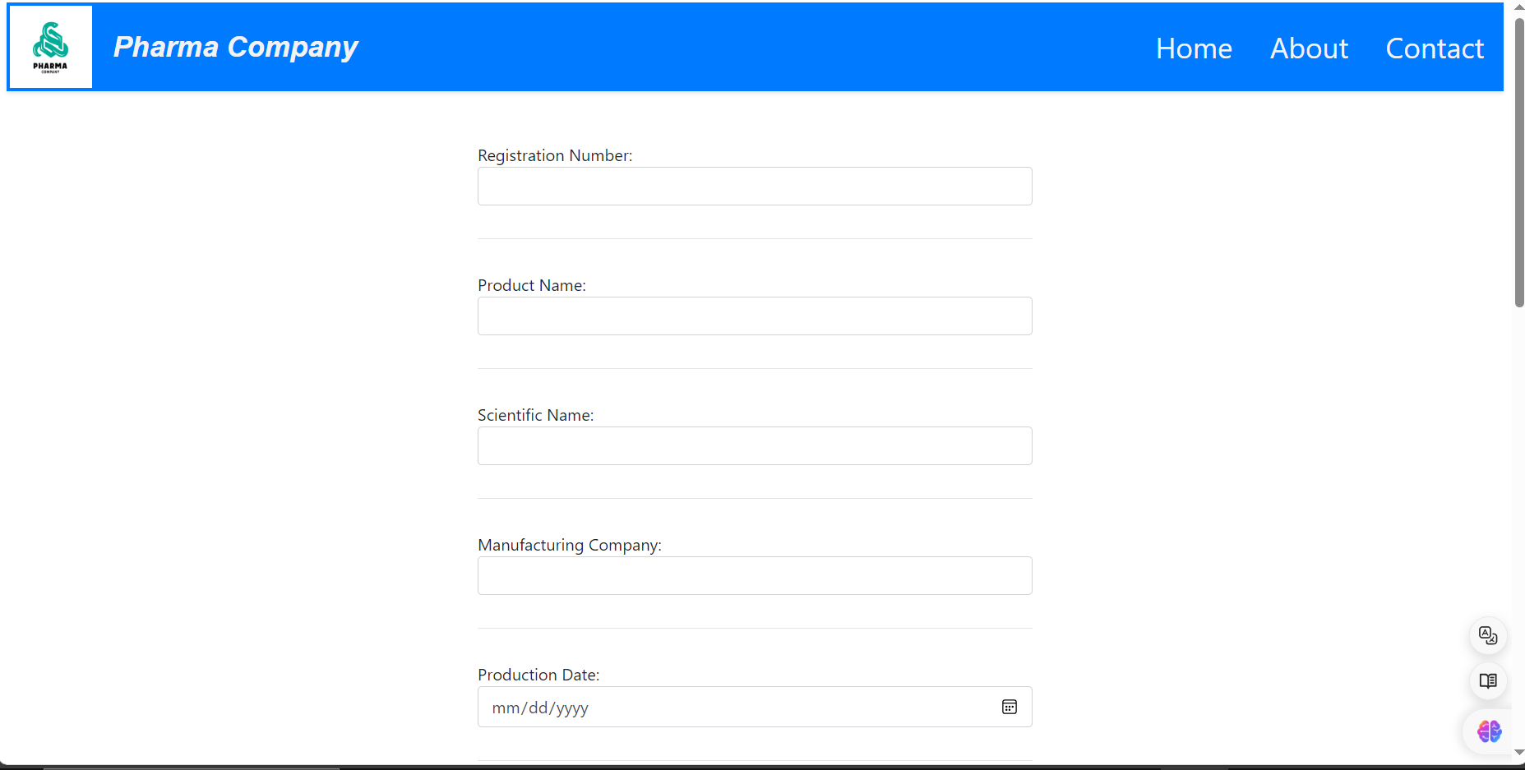

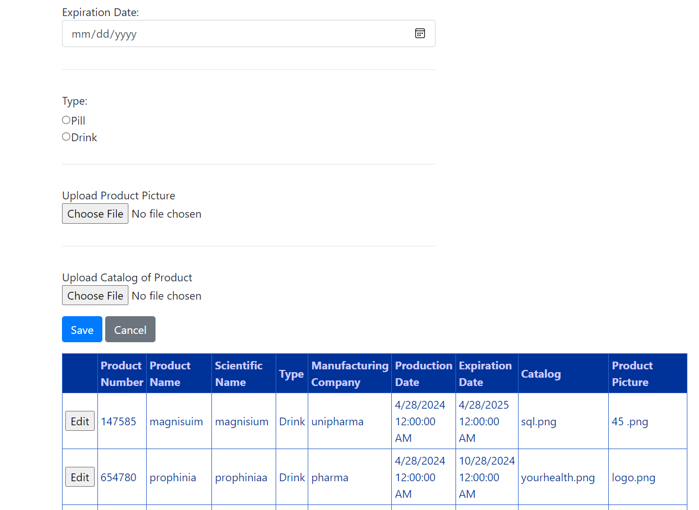

**The Warehouse employee can Insert and Update Products on Database and show operations in grid view. employeeindex.aspx**

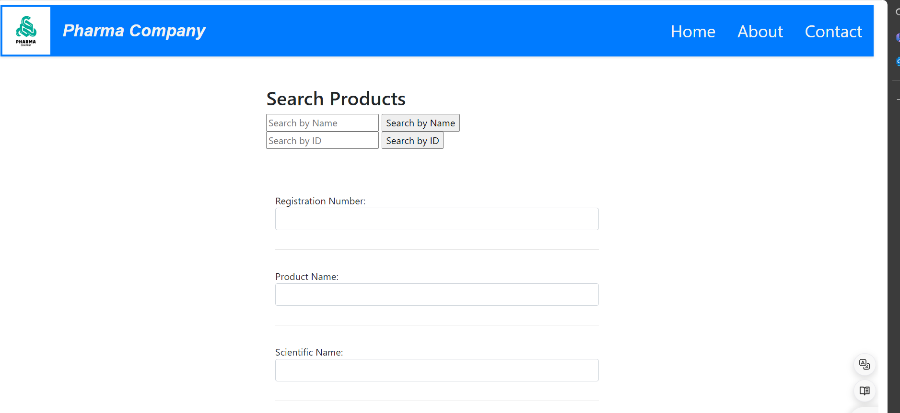

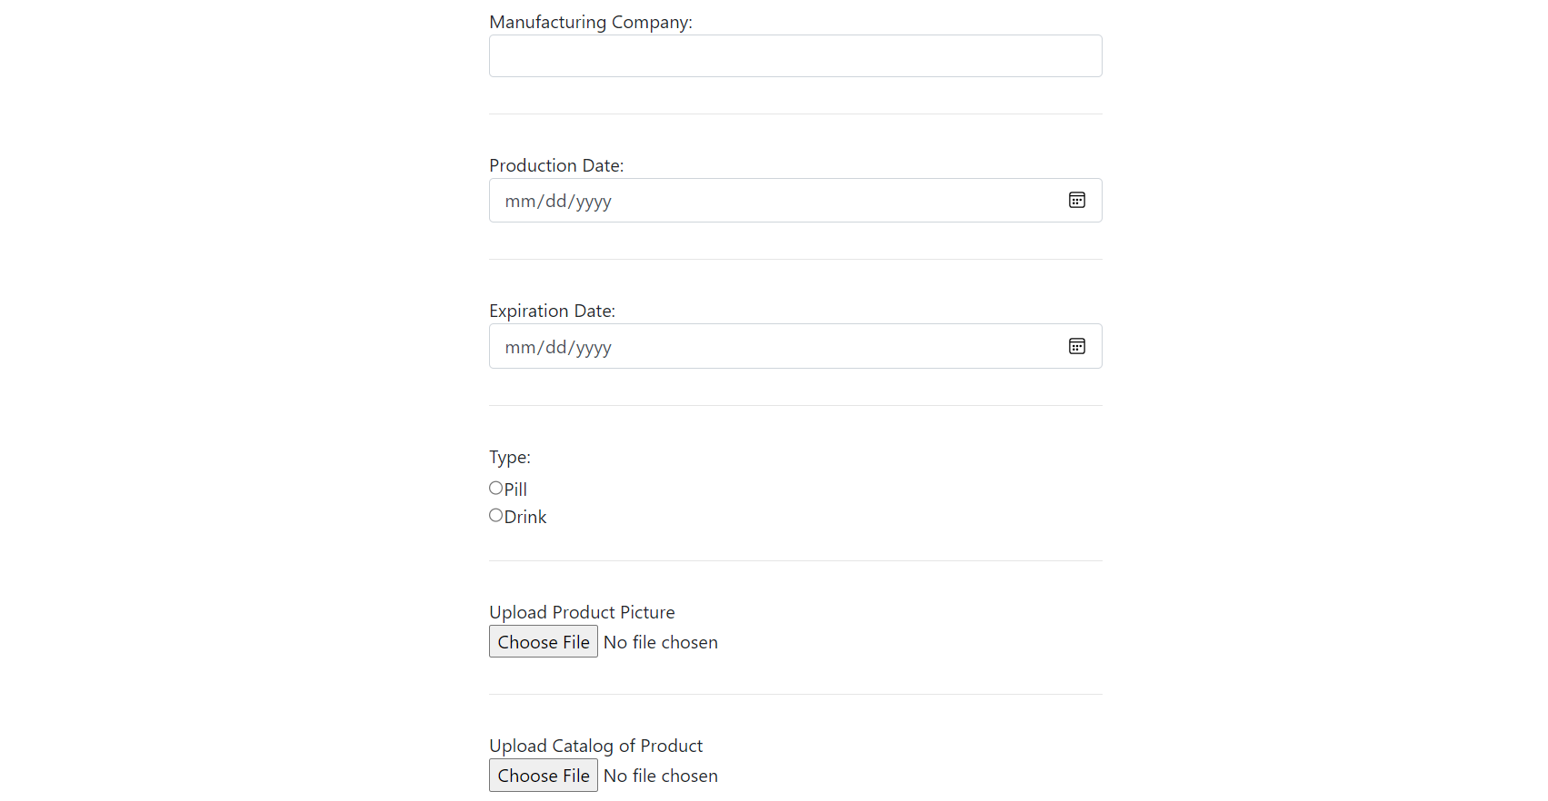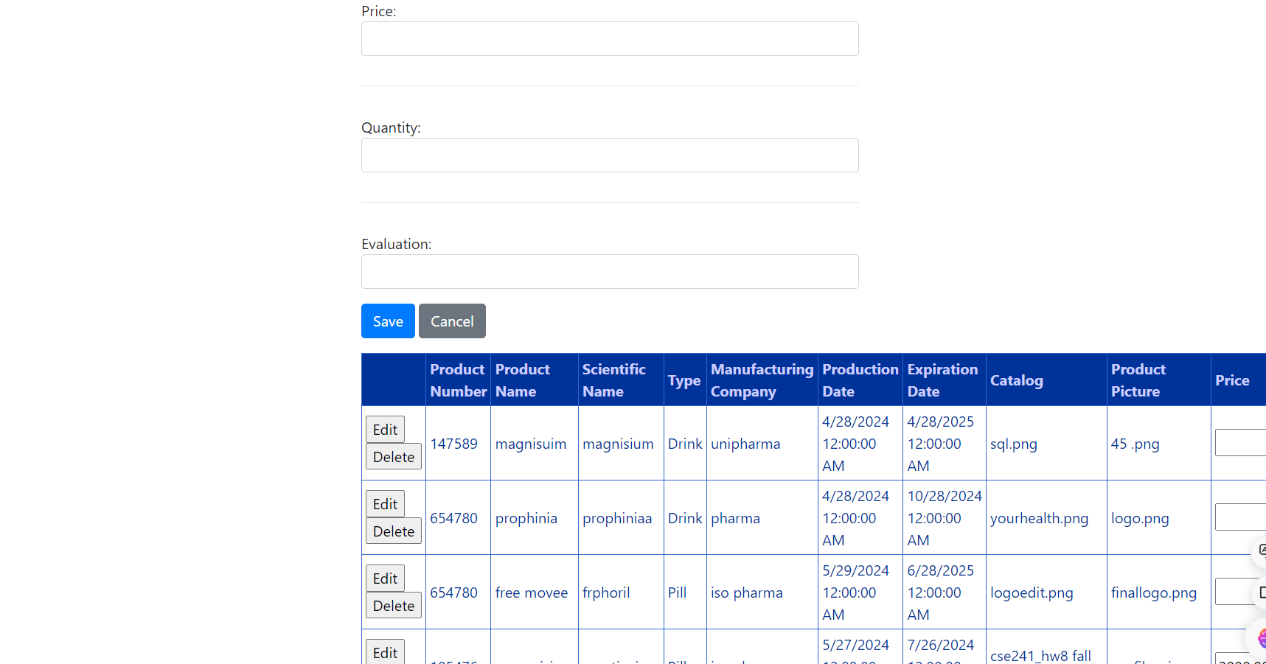

**The Warehouse Manager can Insert Update and Delete and Evaluate Products on Database and show operations in grid view . Index.aspx**

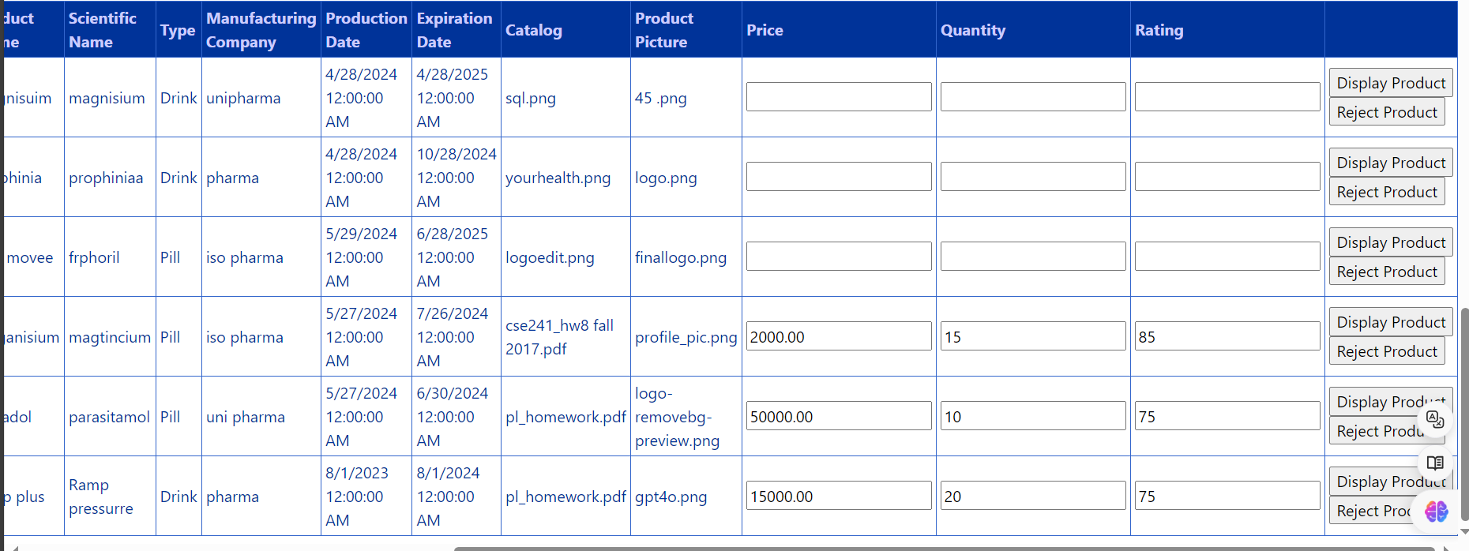

**This Grid View to Display Insert, Update, Delete and Evaluate Operations on Products which connect on database . exist in Index.aspx**

**Marketing :**

This block's primary function is interface to communicate client with cart operations and products the data with orders and storehouse . management to display customers products.

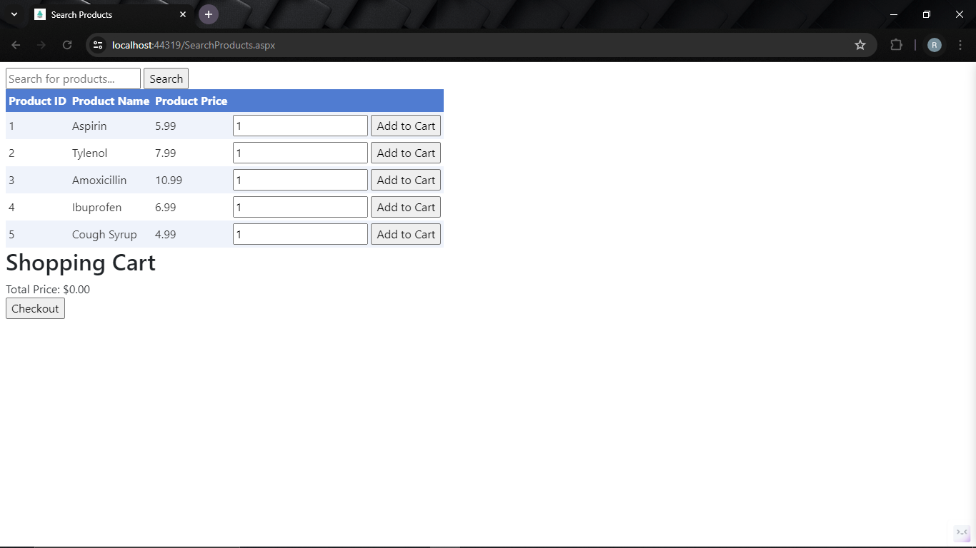

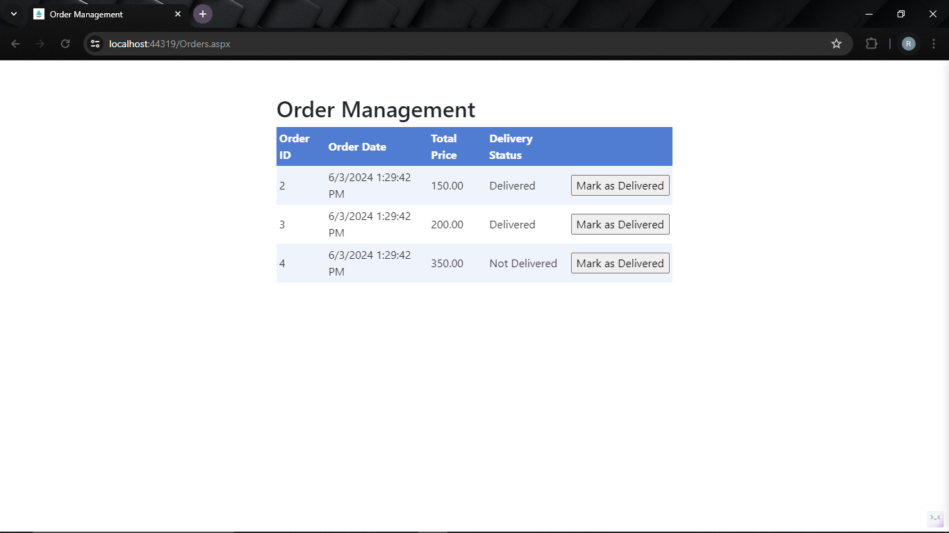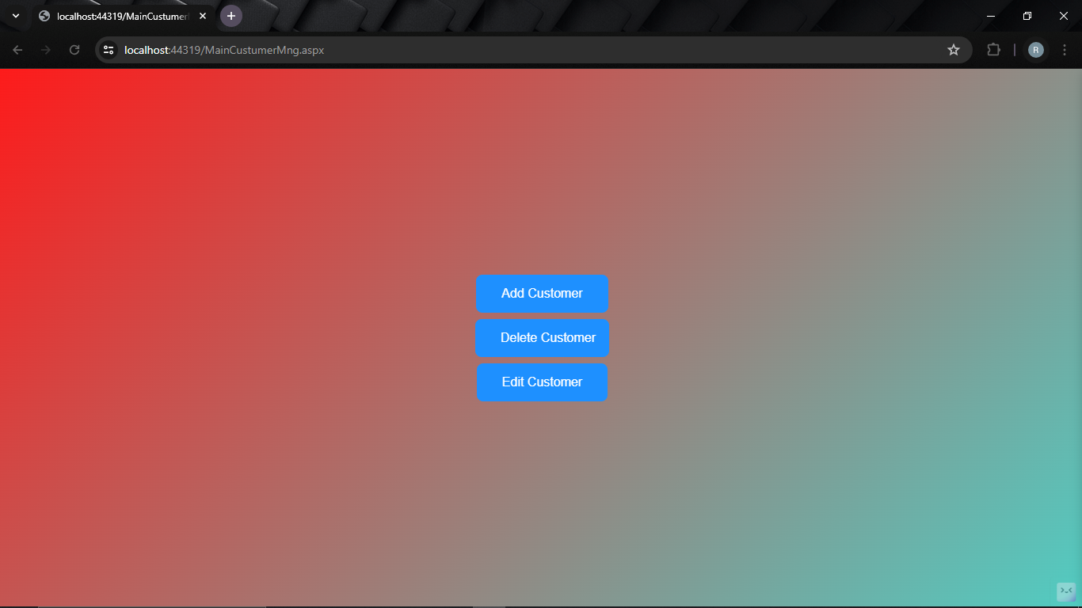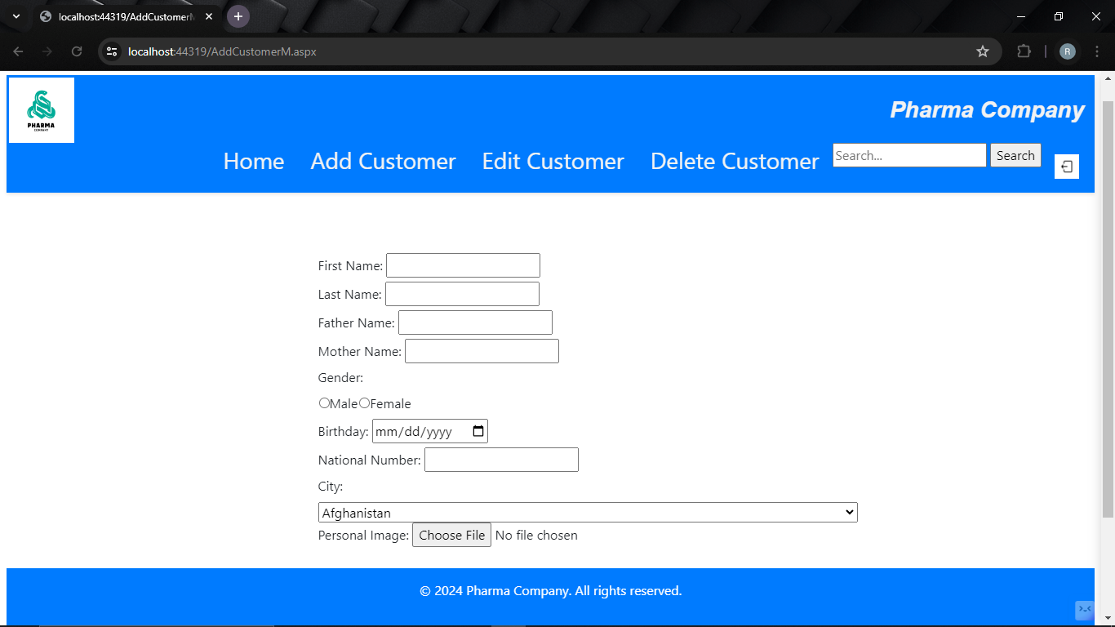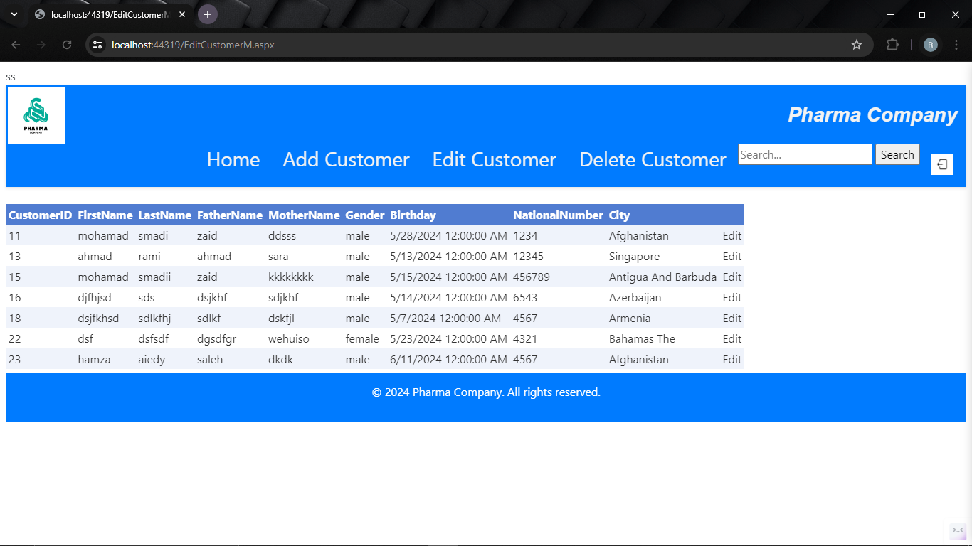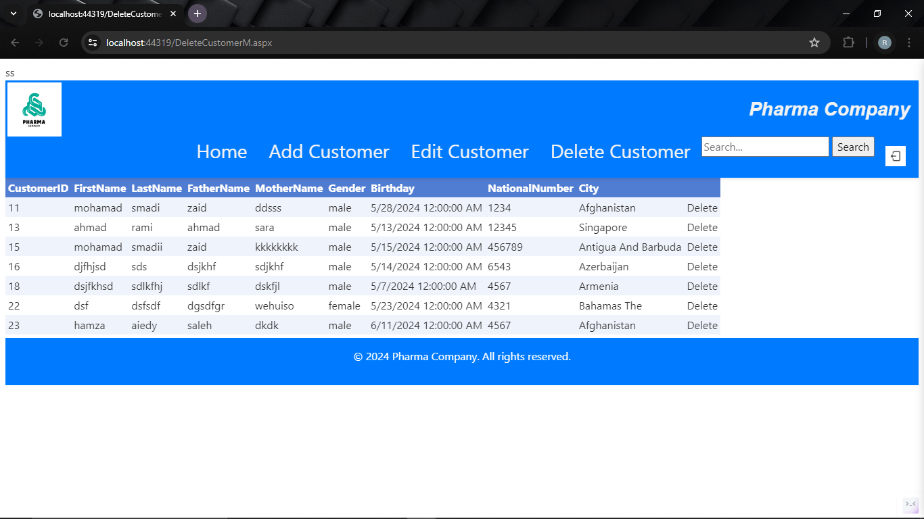

**WORK PARTITION TABLE:**

|  |  |
| --- | --- |
| **Student** | **PAGES DONE BY HIM** |
| **Hamza alaedi** | **-Home**  **- Search**  **-Master Page for all pages**  **products for employee Insert update in page employeeindex.aspx**  **for Manager Insert update delete**  **in page index.aspx**  **evaluation when product rating bigger than 80 to**  **Display ShowRooms** |
| **Rami Yahya** | * **Sign in** * **Home page** * **HR** * **Master page**   **for employee Insert update in page employee_HR.aspx**  **for Manager Insert update delete**  **in page employeemanger.aspx**  **search and download CV**  **evaluation when candidates rating bigger than 70** |
| **Mohmmed Smadi** | **-Master page masterpage.master**  **- Home page mainpagemng.aspx**  **for employee Insert update customers in page insert.aspx edit.aspx**  **for Manager Insert update delete customers**  **in page insert.aspx edit.aspx delete.aspx**  **shopping cart**  **search**  **delivery employee change state of the order** |

**ERD Database Diagrams :**

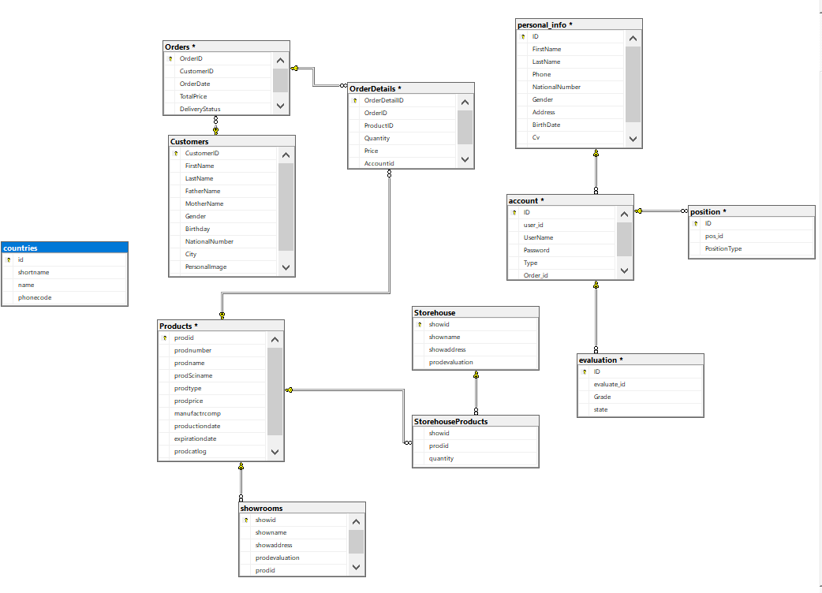

**End of the project.**